Incorporating Air and Water Pollution into the National Income and Product Accounts
Maureen L. Cropper* and Yongjoon Park**

Acknowledgements: We thank Katherine Abraham, Matthew Chambers, David Evans, Eli Fenichel, Charles Griffiths, Peter Maniloff, Al McGartland, Nick Muller, and Scott Wentland for helpful comments.

*Cropper: Department of Economics, University of Maryland, Resources for the Future, 3114H Tydings Hall, College Park, MD 20742 USA
**Park: Department of Resource Economics, University of Massachusetts Amherst, USA.

Introduction
The concept of extending the National Income and Product Accounts to include the environment has been discussed for decades (Ahmad, El Serafy, and Lutz 1989; Nordhaus and Kokkelenberg 1999). Much of the emphasis has been on valuing natural capital (e.g., water resources, forests and minerals); however, other studies have focused on pollution (Muller, Mendelsohn, and Nordhaus 2011). In this paper we discuss the possibility of developing satellite accounts for local and global air pollution and water pollution. This would include core emissions accounts which describe emissions of key air and water pollutants by sector but also monetary estimates of the damages associated with these emissions.
Why is this important? The externalities associated with air and water pollution in the United States are substantial. Carbon dioxide (CO2) emissions in the US in 2020—5.8 gigatons of CO2—imposed damages of $1.12 trillion dollars (2020 USD) if valued using the USEPA’s Social Cost of Carbon (USEPA 2022). The damages associated with air pollution from electric utilities were estimated to be $245 billion in 2010 (2014 USD), but fell to $133 billion in 2017 (2014 USD) (Holland et al. 2020). The value of damages from local air pollution were 6.4% of GDP in 1999 but fell to 3.2% of GDP in 2008 due to improvements in air quality (Muller 2014) Measuring and valuing these externalities will help us as a nation determine how we are progressing in terms of our impacts on the environment.
In this paper we focus on developing satellite accounts for local air pollutants, including the criteria air pollutants, greenhouse gases, and water pollution. In the case of local air pollution, we discuss the resources required to establish core air emissions accounts and the steps required to translate emissions into ambient pollution concentrations and value the impacts of ambient air pollution. Our discussion relies heavily on the pioneering work of Muller, Mendelsohn, and Nordhaus (2011) whose evaluation of Gross External Damages associated with air pollution offers important insights into this process. We also discuss recent estimates by the USEPA of emission damages by sector for the criteria air pollutants (USEPA 2023a). In the case of greenhouse gas emissions, the Bureau of Economic Analysis has constructed pilot supply and use tables for the US in 2017 (Chambers 2023). We present these estimates and discuss how they could be valued using the USEPA’s Social Cost of Carbon.
Water pollution is more challenging. Whereas EPA constructs emissions inventories for greenhouse gas emissions and for the criteria air pollutants, inventories for water pollutants such as biochemical oxygen demand (BOD), phosphorus and nitrogen are more difficult to establish. Progress is being made in modeling non-point source emissions and in estimating their impacts, but the ability to do this on a national scale is not as complete as for air pollution. We discuss what information is currently available to estimate the emissions and impacts of common water pollutants.
When discussing the value of air and water pollution damages we focus on methods currently employed by the USEPA. These methods, while consistent with the best practices of environmental economists, are not necessarily in agreement with the methodology of the National Income and Product Accounts (NIPA). We note areas where the two approaches may not be consistent with each other and where further research is required.

Satellite Accounts for Local Air Pollutants
Constructing satellite accounts for local air pollutants requires assembling a Core Emissions Account reporting emissions of key pollutants for industries and households. Table 1 illustrates a Core Emissions Account (United Nations 2016) for six common air pollutants. Nitrogen oxides (NOx), carbon monoxide (CO), sulfur dioxide (SO2), and fine particulate matter (PM2.5) are criteria pollutants. Ammonia (NH3) may combine with NOx and SO2 to form PM2.5; VOCs, when combined with NOx, form ground-level ozone (O3). The table also shows greenhouse gas emissions, including carbon dioxide, methane, and nitrous oxide (N2O), which are discussed in the next section.
The USEPA’s National Emissions Inventory (NEI), which is published every three years, produces estimates of local air pollutants for both stationary and mobile sources. Estimates are produced for individual stationary sources (e.g., a power plant), and for area sources (e.g., dry cleaners and agricultural operations), road sources and off-road sources at the county level.
To monetize the impacts of these emissions requires translating emissions into changes in ambient air quality, estimating the effects of changes in ambient air quality on health and other endpoints, and then valuing these impacts. Using the 2002 NEI, Muller, Mendelsohn, and Nordhaus (2011) estimated the impacts of the local pollutants listed in Table 1 on mortality, morbidity, agricultural and timber yields, visibility and recreation. We describe their results and discuss the insights that these estimates provide.

Muller, Mendelsohn, and Nordhaus Estimates of Gross External Damage
The goal of Muller, Mendelsohn, and Nordhaus (2011) was to provide a framework for estimating the externalities associated with air pollution. To do this, they combined the 2002 NEI with an Integrated Assessment Model (APEEP), which translated emissions of each of six pollutants, by county, into changes in ambient pollution throughout the US. The impacts of these pollutant changes were estimated using damage functions for various endpoints, and the damages valued in 2000 dollars.
To illustrate, suppose that a ton of PM2.5 is emitted at ground level in Los Angeles county. A source-receptor matrix translates this emission into changes in ambient PM2.5 in Los Angeles county and in all other counties affected by this release. Together with data on population, the incidence of various health endpoints and dose-response functions, the impact of this ton can be translated into changes in mortality and morbidity in each county whose ambient air quality is affected by the ton emitted. These marginal changes in health endpoints can, in turn, be valued, and summed, to estimate the health damages caused by the ton of PM2.5 emitted at ground level in Los Angeles county. Damages associated with other impacts (e.g., on agriculture or on visibility) can be added to health damages.
Figures 1-3 show the outputs of the APEEP model for three pollutants: PM2.5, SO2 and VOCs (Muller and Mendelsohn 2009). Figure 1 shows the damages from emitting a ton of PM2.5 at ground level in each county in the US in 2002. Damage categories reflected in these estimates include mortality, morbidity, and damages to agriculture, forestry and recreation. A ton of PM2.5 emitted at ground level in Los Angeles county imposes damages in excess of $20,000 (2000 USD). Damages from emitting PM2.5 are greatest when estimated in densely populated areas. The damages per ton of SO2 (Figure 2) and per ton of VOCs (Figure 3) are less than for PM2.5. This reflects the fact that the health effects associated with PM2.5 are greater than for SO2—although SO2 may combine with ammonia to form PM2.5. VOCs combine with NOx to form ground-level ozone (O3); however, the health damages associated with O3 (per μg/m3) are less costly than for PM2.5 (per μg/m3).
Muller, Mendelsohn, and Nordhaus (2011) also identify the sectors responsible for the largest air pollution damages and the damage categories that account for the majority of damages. Table 2 presents estimates of Gross External Damages (GED) by sector, as well as the ratio of GED to value added by sector. Electric utilities—dominated in 2002 by coal-fired power plants—account for one-third of total GED. Together, agriculture and forestry, electric utilities, transportation and manufacturing account for 78 percent of GED. Table 3 elaborates on the damages of emissions from coal-fired power plants. The table reports damages by pollutant and also by category of damage. Emissions of SO2, which are converted into PM2.5, account for 86 percent of power-plant damages. Damages, by category, are dominated by premature mortality, which accounts for 95 percent of damages.
How is premature mortality valued? Muller, Mendelsohn, and Nordhaus (2011) value premature mortality using the USEPA’s estimate of the Value per Statistical Life (VSL). The VSL is the amount that people would pay to reduce their risk of death by a small amount, aggregated over risks that sum to one statistical life. For example, if each of 10,000 people would pay $200 to reduce their risk of death by 1 in 10,000, the VSL equals 10,000 x $200 or $2 million. EPA’s estimate of the VSL is based primarily on hedonic labor market studies, which measure the compensation that workers receive for working in riskier jobs. The VSL is, therefore, based on market prices. EPA’s estimate of the VSL, in 2000 dollars, is $6.3 million (USEPA 2023a). The VSL, as applied by EPA, does not vary with age at death: it values the death of a 40-year-old the same as the death of a 70-year-old.
The estimates of GED in Tables 2 and 3 value premature deaths by life-years lost. Muller, Mendelsohn, and Nordhaus (2011) take the USEPA’s VSL and divide it by the discounted remaining life expectancy of a 40-year-old (the average age of workers in compensating wage studies) to compute a Value per Statistical Life Year (VSLY). Premature deaths are valued using the number of life years lost multiplied by the VSLY. How does this affect estimates of GED, compared to using a VSL that does not vary with age? Using the VSLY, total air pollution damages are 184 billion 2000 USD (1.8% of 2002 GDP). Using the VSL, air pollution damages increase to 460 billion 2000 USD (4.4% of 2002 GDP). These figures illustrate the importance of how mortality is valued in estimating air pollution damages.

USEPA Estimates of Air Pollution Damages per Ton of Pollutant
In 2022, EPA released estimates of the cost per ton of pollutant for 21 sectors and five pollutants using the 2017 NEI. Air quality modeling was used to estimate source-receptor matrices for each sector-pollutant combination at a 12km x 12km resolution (USEPA 2023a). To illustrate, Figures 4-6 show estimated impacts of emissions from oil and gas extraction on annual average PM2.5 and maximum daily 8-hour ozone (averaged over the summer ozone season), and the estimated impacts of emissions from woodburning stoves on annual average PM2.5. Oil and gas extraction in areas around extraction sites (Figure 4) was estimated to raise ambient PM2.5 by as much as 0.2 μg/m3, and in some cases, 0.3 μg/m3. To put these numbers in perspective, the annual average PM2.5 standard is 12 μg/m3. The impact of woodburning stoves on PM2.5 (Figure 6) is even greater, raising PM2.5 by over 0.3 μg/m3 in some areas. The impacts of oil and gas extraction on ground level ozone (Figure 5) extend over larger areas than the PM2.5 impacts because ozone can travel for hundreds of miles. In Texas and surrounding states, ozone concentrations were estimated to increase by 5 ppb. To put this in perspective, the 8-hour ozone standard is 70 ppb.
The impacts of changes in ambient concentrations on pollution damage were also estimated at a 12km x 12km resolution using the USEPA’s BenMAP, an Integrated Assessment Model that links changes in ambient air pollution concentrations to health and other endpoints and then values these endpoints (Sacks et al. 2018; USEPA 2023b). Although BenMAP covers all of the pollutants and endpoints in Table 2, over 98% of the monetized damages associated with emissions come from the mortality impacts of PM2.5 and ozone. These impacts were monetized using a VSL of 10.7 million 2016 dollars.
Table 4 illustrates estimated pollution damages by sector and pollutant. PM2.5 damages come from directly emitted PM2.5, or from secondary PM2.5, formed when SO2 or NOx combine with ammonia. Air quality modeling has been used to trace secondary PM2.5 back to its precursors. The same has been done for ozone precursors. Marginal damages associated with emissions of each pollutant have been averaged across all locations in the US. Marginal health damages associated with any pollutant are greater if the emissions occur near densely populated areas. This explains the high damages per ton of directly emitted PM2.5 for residential wood stoves (see Figure 6) and refineries compared to oil and natural gas extraction (see Figure 4). The lower damages per ton for ozone precursors reflect the fact that the mortality impacts of ozone are lower per unit than for PM2.5 (USEPA 2023a). The higher damages associated with NOx precursors of ozone reflects the fact that in many areas, ozone production is NOx limited.

Implications for the NIPA
The material we have reviewed suggest that the US should be able to construct preliminary satellite accounts for local air pollutants. Constructing satellite accounts for local air pollutants requires estimates of emissions of each pollutant by sector. It should be possible to do this for the criteria air pollutants using the National Emissions Inventory, which is issued every three years. Monetizing these damages requires that emissions estimates be made at a fine enough spatial scale to be translated into levels of ambient air pollution which can, in turn, be monetized and valued. Air quality modeling can then be used to translate damages back to the source of emissions. This is currently being done by the USEPA, focusing on the impact of emissions of directly emitted PM, NOx, SO2, VOCs and ammonia on PM2.5 and ground level ozone.
As noted above, premature mortality accounts for the vast majority of monetized damages from local air pollution, and is valued using the Value per Statistical Life, estimated based on compensating wage studies. This raises two issues. The VSL values the present value of lost utility from dying in a particular year. Thus, it values the present value of a flow of damages from pollution and represents the value of a stock. In the NIPA, the flow of services from a durable good (a stock) are not credited to GDP in the year the good is produced; rather, the flow of services from the stock are credited to GDP in the year in which they occur. Thus, there is a stock-flow issue that must be addressed.
The second issue deals with the extrapolation of the VSL from compensating wage studies to the general population. Compensating wage studies measure the value that workers place on mortality risks—i.e., the amount they must be compensated to bear additional risk of death on the job. The fact that this value is based on market transactions is acceptable to the NIPA; however, it measures the value to the people who bear the risks. It is not clear that this value may be extrapolated to people who do not bear the risks, as an estimate of the value they place on mortality risks.

Satellite Accounts for Global Air Pollution
EPA produces annual estimates of global air pollutants, including carbon dioxide, methane, and nitrous oxide, implying that it is possible to construct a core air emissions table (see Table 1) for GHG emissions. A pilot Supply and Use table (Table 5) prepared by the Bureau of Economic Analysis (Chambers 2023), shows the sources of GHG emissions in 2017, by sector. Utilities, manufacturing and households together account for two-thirds of the 6.4 billion tons of CO2e emitted in 2017. Note that in Table 5, emissions of individual GHGs have been weighted by their global warming potential. Of the 6.4 billion tons of CO2e emitted in 2017, 79% came from carbon dioxide, 11% from methane and 6% from nitrous oxide (USEPA 2022).
These emissions could be valued using the USEPA’s Social Cost of Carbon, Social Cost of Methane and Social Cost of Nitrous Oxide (USEPA 2022). To explain how these estimates are calculated, we focus on the Social Cost of Carbon (SCC). The SCC measures the present value of the net damages from emitting a ton of CO2 in a particular year. Due to the long residence times of CO2 in the atmosphere—30% of a ton of CO2 emitted today will remain in the atmosphere in the year 2300 (Joos et al. 2013)—estimating the SCC requires predicting what the world will look like in the future. EPA’s estimates of the SCC follow the approach suggested by the National Research Council (National Academies of Sciences, Engineering, and Medicine 2017): A Socio-Economic module is used to construct probability distributions over future paths of population, per capita GDP and GHG emissions; a climate module translates future emissions paths into paths of mean global temperature, downscaled to estimate regional temperatures and impacts on sea level rise; a damages module relates changes in temperature associated with a pulse of CO2 to damages along each socio-economic pathway. Along each pathway, damages are discounted to the present, to yield a probability distribution of SCC values. The mean of this distribution, referred to as the SCC, is used to value CO2 emissions.
EPA’s most recent estimates of the SCC rely on different sources for their damage estimates: the RFF GIVE model (Rennert et al. 2022), the Data-driven Spatial Climate Impact Model (DSCIM) damage estimates from the Climate Impact Lab (Climate Impact Lab) and a meta-analysis of damage estimates by (Howard and Sterner 2017). These damage estimates encompass the impacts of temperature on mortality, on agriculture, on sea level rise, energy and labor productivity. These damages are global damages. The impacts of temperature on premature mortality, which comprise 73% of damages in DCSIM model and 47% of damages in the GIVE model, are valued using a VSL of 10.05 million 2020 USD, which is extrapolated to other countries based on per capita GDP, using an income elasticity of one.
Estimates of the SCC provided by all three models are given in Table 6. EPA discounts future damages along each socio-economic pathway using a Ramsey formula. Parameters of the formula are chosen so that near-term discount rates equal 1.5%, 2% or 2.5%. The preferred estimates of the SCC, shown in Table 6, use Ramsey parameters tied to a 2% near-term discount rate. The SCC in 2020, averaged across the three models, is $193 (2020 USD). This implies that the damages associated with US emissions of CO2 in 2020 were approximately 1.12 trillion dollars. Note that the SCC increases over time because the CO2 emitted occurs in a warmer, richer world. To illustrate: the SCC associated with a ton emitted in 2030 is $230 (2020 USD) and $267 (2020 USD) for a ton emitted in 2040.
Social costs have also been estimated for methane and nitrous oxide. Due to the greater GWP of these gases, and the fact that their impacts occur closer to the present, the social cost of a ton of methane emitted in 2020 is $1,648 and the social cost of a ton of nitrous oxide emitted in 2020 is $54,139.

Implications for the NIPA
The methods used to estimate and value damages in computing the SCC raise issues similar to those discussed in valuing local pollutants, as well as new issues. Because the SCC values the damage from emitting a ton of CO2 today as the present value of the flow of damages it generates, i.e., using a stock concept, this raises the stock-flow issues discussed above. In terms of the categories of damages valued, heat-related mortality is valued using the US VSL, extrapolated to other countries using an income elasticity of one. This raises the extrapolation issues discussed above. It is also important to check that all damage estimates reflect marginal prices, rather than consumer surplus.
A more serious issue from the perspective of the NIPA is whether it is appropriate to include in the satellite account damages from US CO2 emissions that occur in other countries. The damages from local air pollution discussed in section II are damages from emissions in the US that occur in the US. Damages in the USEPA’s SCC are global damages. Whether these can be included in satellite accounts remains to be determined.

Satellite Accounts for Water Pollution

Constructing satellite accounts for water pollution requires estimates of water pollutants by sector. Table 7 shows a physical supply table for gross releases of substances to water, by sector, including BOD, suspended solids, heavy metals, phosphorous and nitrogen. What are the sources of such releases in the United States? The National Pollutant Discharge Elimination System (NPDES) covers emissions from point sources, including animal feeding operations, fish farms, industrial operations, including mining and oil and gas drilling, storm water discharges and municipal wastewater treatment facilities. Discharges from these sources are collected in Discharge Monitoring Reports (USEPA 2023c), available by state and year.
Substances released to water from non-point sources (e.g., agricultural runoff) are often modeled using EPA’s Hydrologic and Water Quality System (HAWQS). HAWQS simulates the effects of management practices for a variety of crops, soils, natural vegetation types, and land uses, to generate estimates of sediment, pathogens, nutrients, BOD, dissolved oxygen, pesticides and water temperature. Currently, HAWQS is not used to generate annual estimates of non-point source releases, by state and sector, similar to the data that are available in the NPDES.
To estimate the impact of all releases to rivers and streams on ambient water quality, releases from point sources may be added to HAWQS and the model used to generate estimates of ambient water quality (e.g., dissolved oxygen, total suspended solids, BOD, nitrogen, phosphorous and fecal coliform). This is usually done at the watershed level. The change in damages associated with a change in ambient water quality is then estimated and valued using BenSPLASH: the water quality counterpart to BenMAP (Corona et al. 2020).
Valuing changes in ambient water quality is more difficult than valuing changes in air quality. The majority of monetized air pollution damages are associated with two pollutants—PM2.5 and ozone—and, over 90% of monetized damages are associated with the mortality impacts of these pollutants. Measures of water quality such as dissolved oxygen, total suspended solids, BOD, nitrogen, phosphorous, fecal coliform, are associated with a variety of endpoints: improved commercial and recreational fishing, improved swimming and boating, improved aesthetic benefits and ecosystem services. Whereas the same exposure-response functions relating PM2.5 to mortality can be applied to everyone in the US, the impact of dissolved oxygen on commercial fishing will vary from one location to another, as will the recreational benefits of cleaner water.
To deal with the multiplicity of pollutants and benefit categories, BenSPLASH combines six measures of water quality—dissolved oxygen, fecal coliform, nitrogen, phosphorous, BOD and total suspended solids—into a water quality index (WQI). Stated preference valuation functions are combined in a meta-regression to estimate willingness to pay for changes in the WQI (USEPA 2015). Specifically, EPA has combined 51 stated preference studies that value water quality changes affecting ecosystem services provided by water bodies, including recreational fishing, boating and swimming, aquatic life support and nonuse values. Willingness to pay is computed for all households within the watershed where changes in water quality are evaluated (Corona et al. 2020).
BenSPLASH uses benefits transfer and stated preference studies to derive a valuation function for water quality benefits that can be applied nationally. Because the NIPA rely on market transactions as measures of value, stated preference estimates would not be admissible in the satellite accounts. Alternatives that have been proposed to measuring water quality benefits using market prices have focused on examining the capitalization of water quality into housing prices (Guignet et al. 2019; Keiser and Shapiro 2018), and impacts of water quality on commercial fisheries. These approaches cannot, however, capture all of the benefits of improved water quality.

Conclusion
The purpose of this paper has been to provide a brief review of the data that are available on emissions of air and water pollutants in the United States and the attempts that have been made to value the damages associated with these pollutants. This is only the beginning of constructing satellite accounts for air and water pollution. We have not discussed the expenditures by consumers and firms that are made to reduce pollution, nor have we discussed which categories of damages are already incorporated in the National Income and Product Accounts (e.g., damages to commercial fisheries from water pollution), although these could also be incorporated in satellite accounts.
Quantifying pollution emissions and valuing pollution damages would, however, serve to highlight the importance of these externalities, most of which are not captured in the National Income and Produce Accounts. They would also serve as a compliment to the environmental activity accounts being developed by the BEA (Fixler et al. 2023), which value economic activities whose “primary purpose is to reduce or eliminate pressures on the environment.”

It would make sense to begin with satellite accounts for local and global air pollution. For local air pollution, emissions of criteria air pollutants or their precursors are available through the National Emissions Inventory by sector and geographic location. EPA currently provides estimates of the mortality and morbidity damages from these pollutants, for 21 sectors. In the case of Greenhouse Gas emissions, the BEA has already produced a proof-of-concept Physical Flows Account for GHGs (Chambers 2023). These emissions could be valued using the federal Social Cost of Carbon, Social Cost of Methane and Social Cost of Nitrous Oxide, although adjustments to current estimates of the Social Cost of Carbon, Social Cost of Methane and Social Cost of Nitrous Oxide would likely be necessary, for reasons discussed above. Producing physical flows accounts for water pollution emissions and estimates of their damages is, however, a task for the future.

Tables and Figures

Tables
Table 1. Core Air Emissions Account (unit: tonnes)
 | Industries |  |  |  |  | Households
 | Agriculture | Mining | Manufacturing | Transport | Other | Transport | Heating | Other
Panel A: Local Air Pollutants
NOx | 69.4 | 6.0 | 37.9 | 259.5 | 89.0 | 38.0 | 12.1 | 1.3
CO | 41.0 | 2.5 | 123.8 | 46.2 | 66.2 | 329.1 | 51.2 | 5.7
VOC | 5.2 | 6.5 | 40.0 | 16.4 | 27.2 | 34.5 | 29.4 | 3.2
PM | 7.0 | 0.1 | 8.5 | 9.3 | 4.4 | 6.0 | 2.8 | 0.5
NH3 | 107.9 |  | 1.7 | 0.2 | 0.9 | 2.3 | 11.4 | 1.2
SO2 | 2.7 | 0.4 | 28.0 | 62.4 | 8.1 | 0.4 | 0.4 | 0.1
Panel B: Greenhouse Gasses
Carbon Dioxide | 10,610.3 | 2,602.2 | 41,434.4 | 27,957.0 | 82,402.4 | 18,920.5 | 17,542.2 | 1,949.1
Methane | 492.0 | 34.1 | 15.8 | 0.8 | 21.9 | 2.4 | 15.5 | 1.7
N2O | 23.7 |  | 3.5 | 0.8 | 2.6 | 1.0 | 0.2 | 0.1
F-GHGs |  |  | 0.3 |  | 0.4
Sulphur Hexafluoride
Nitrogen Triflouride
Source: Core Account 1, (United Nations 2016)
Note: This table illustrates the generation of air emissions by industries and households, by type of substance. Air emissions are broken down by industry sectors (i.e. agriculture, mining, manufacturing, and transport) and by household purposes (i.e. transport, heating, other). Pollutants are grouped by local and greenhouse gasses. The reported local pollutants include nitrogen oxides (NOx), carbon monoxide (CO), volatile organic compounds (VOC), particulate matter (PM), ammonia (NH3), and sulfur dioxide (SO2). The reported pollutants for greenhouse gas emissions include carbon dioxide, methane, and nitrous oxide (N2O), fluorinated greenhouse gases (F-GHGs), sulphur hexafluoride and nitrogen triflouride.
Table 2. Gross External Damages and GED/VA Ratio by Sector
Sector | GED | GED/VA
Agriculture and forestry | 32.0 | 0.38
Utilities | 62.6 | 0.34
Transportation | 23.2 | 0.10
Administrative, waste management, and remediation services | 10.7 | 0.08
Construction | 14.7 | 0.03
Arts, entertainment, and recreation | 2.2 | 0.03
Accommodation and food services | 4.2 | 0.02
Mining | 3.3 | 0.02
Manufacturing | 26.4 | 0.01
Other services | 1.0 | 0.01
Wholesale trade | 1.2 | 0.00
Retail trade | 1.7 | 0.00
Information | 0.0 | 0.00
Finance and insurance | 0.0 | 0.00
Real estate services | 0.0 | 0.00
Professional, scientific, and technical services | 0.0 | 0.00
Management | 0.0 | 0.00
Educational services | 0.0 | 0.00
Health care services | 0.7 | 0.00
Total all sectors | 184.0
Source: Table 1 of Muller, Mendelsohn, and Nordhaus (2011)
Note: The table presents data on Gross External Damages (GED) and its ratio to Value Added (VA) for different sectors of the economy in the year 2002. GED is measured in billions of dollars per year (in 2000 USD).

Table 3. GED for Coal-Fired Power Plants by Pollutant and Type of Damage
Pollutant/welfare endpoint | SO2 | PM2.5 | PM10 | Nox | VOC | NH3 | Total
Mortality | 44.2 | 3.53 | 0 | 2.75 | 0.03 | 0.09 | 50.6
Morbidity | 1.64 | 0.03 | 0.12 | 0.18 | 0 | 0 | 1.97
Agriculture | 0 | 0 | 0 | 0.37 | 0 | 0 | 0.37
Timber | 0 | 0 | 0 | 0.02 | 0 | 0 | 0.02
Materials | 0.06 | 0 | 0 | 0 | 0 | 0 | 0.06
Visibility | 0.22 | 0.01 | 0.02 | 0.02 | 0 | 0 | 0.26
Recreation | 0 | 0 | 0 | 0 | 0 | 0 | 0
Total | 46.12 | 3.57 | 0.14 | 3.34 | 0.03 | 0.09 | 53.4
Source: Table 4 of Muller, Mendelsohn, and Nordhaus (2011)
Note: The table shows the gross external damages (GED) of emissions from coal-fired power plants in the year 2002. The table reports damages by pollutant and also by category of damage. The damage is measured in billions of dollars per year (in 2000 USD).

Table 4. Summary of the Total Damages (Mortality and Morbidity) per Ton in 2025, By Sector
 | PM2.5-Related Benefits |  |  |  | Ozone-Related Benefits
Sector | Direct PM2.5 | SO2 | NOx | NH3 | NOx | VOC
Oil and Natural Gas | $97,900 | $19,400 | $8,080 | $23,900 | $44,900 | $1,680
Oil and Natural Gas Transmission | $138,000 | $29,800 | $13,700 | $73,400 | $61,200 | $7,490
Pulp and Paper | $145,000 | $39,300 | $11,200 | $51,100 | $75,700 | $2,130
Refineries | $368,000 | $50,900 | $23,100 | $112,000 | $57,500 | $11,500
Residential Woodstoves | $473,000 | $34,600 | $33,100 | $200,000 | $39,000 | $12,300
Synthetic Organic Chemical | $140,000 | $42,800 | $17,000 | $71,200 | $70,300 | $5,540
Taconite Mining | $60,600 | $32,800 | $9,230 | -- | $45,800 | $29,600
Electricity Generating Units | $137,000 | $73,000 | $6,400 | -- | $111,000 | --
Brick Kilns | $227,000 | $44,000 | $26,900 | $130,000 | $78,800 | $10,700
Cement Kilns | $157,000 | $42,300 | $14,600 | $63,900 | $68,900 | $16,900
Coke Ovens | $281,000 | $53,500 | $25,600 |  | $61,500 | $33,400
Ferroalloy Facilities | $151,000 | $45,300 | $15,600 |  | $95,900 | $7,230
Industrial Boilers | $192,000 | $42,300 | $15,200 | $85,600 | $64,800 | $13,200
Integrated Iron & Steel | $384,000 | $53,700 | $23,600 | $190,000 | $69,900 | $13,300
Internal Combustion Engines | $166,000 | $38,700 | $10,700 | $75,300 | $54,800 | $8,510
Iron and Steel Foundries | $261,000 | $54,300 | $24,000 |  | $84,700 | $7,410
Source: USEPA (2023b)
Note: The table illustrates pollution damages (mortality and morbidity) per ton of directly emitted PM2.5 and PM2.5 precursors produced by sector in 2025. Similar figures are produced for ozone precursors. The unit is 2016 USD and 3% of the discount rate is used for this calculation.

​​Table 5. 2017 Supply and Use Table for GHGs
Sector | Total GWP | Sector | Total GWP
Agriculture | 611.83 | Professional | 15.79
Mining | 300.02 | Management | 9.79
Utilities | 2152.34 | Administrative | 180.61
Construction | 46.49 | Education | 7
Manufacturing | 1028.84 | Health Care | 22.85
Wholesale | 67.66 | Entertainment | 2.54
Retail | 91.91 | Hospitality | 34.64
Transportation | 657.49 | Other Services | 18.88
Information | 8.1 | Government | 33.25
Finance | 9.61 | Households | 1108.21
Real Estate | 24.03 | Total Supply | 6431.87
Source: Table 1 of Chambers (2023)
Note: This supply and use table shows the sources of greenhouse gas emissions in 2017 by sector. Units, reflecting global warming potential (GWP) are megatonnes of CO2 equivalent.
Table 6. Social Cost of CO2, 2020 - 2050
 | Damage Module
Emission Year | DSCIM | GIVE | Meta-Analysis
2020 | 190 | 190 | 200
2030 | 230 | 220 | 240
2040 | 280 | 250 | 270
2050 | 330 | 290 | 310
Source: USEPA (2022)
Note: This table shows the estimates of the Social Cost of Carbon in 2020-2050 using three different models — i) the Data-driven Spatial Climate Impact Model (DSCIM); ii) damage estimates from the RFF GIVE model; and iii) a meta-analysis of damage estimates by Howard and Sterner (2017). The unit is 2020 USD per metric tons of CO2. A near-term Ramsey discount rate of 2% is used for the calculations.
Table 7. Physical Supply Table for Gross Releases of Substances to Water
 | Generation of gross releases to water |  |  | Accumulation | Flows with the rest of the world | Flows from the environment | Total supply
 | Sewerage Industry | Other Industries | Households | Emissions from fixed assets |  | Flows from the environment | Total supply
Emissions received by the environment
BOD | 5,594 | 11,998 | 2,712 |  |  |  | 20,304
Suspended solids
Heavy metals
Phosphorus | 836 | 1,587 | 533 |  |  |  | 2,956
Nitrogen | 10,033 | 47,258 | 1,908 |  |  |  | 59,199
Source: United Nations (2012)
Note: Table 7 is a physical supply table for gross releases of substances to water by sector. The figures are reported in tonnes.

Figures

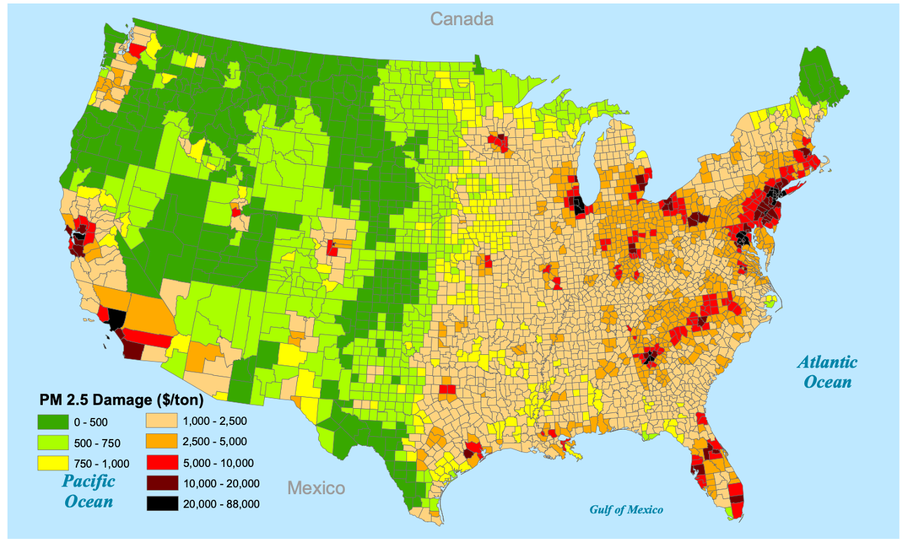
Figure 1. Marginal Damages from Ground Level PM2.5 Emitted in 2002

Source: Muller and Mendelsohn (2009)
Note: This figure illustrates the geographical variation in marginal damages due to PM2.5 emitted in 2002. The unit of damage is dollar per ton per year, in 2000 USD.

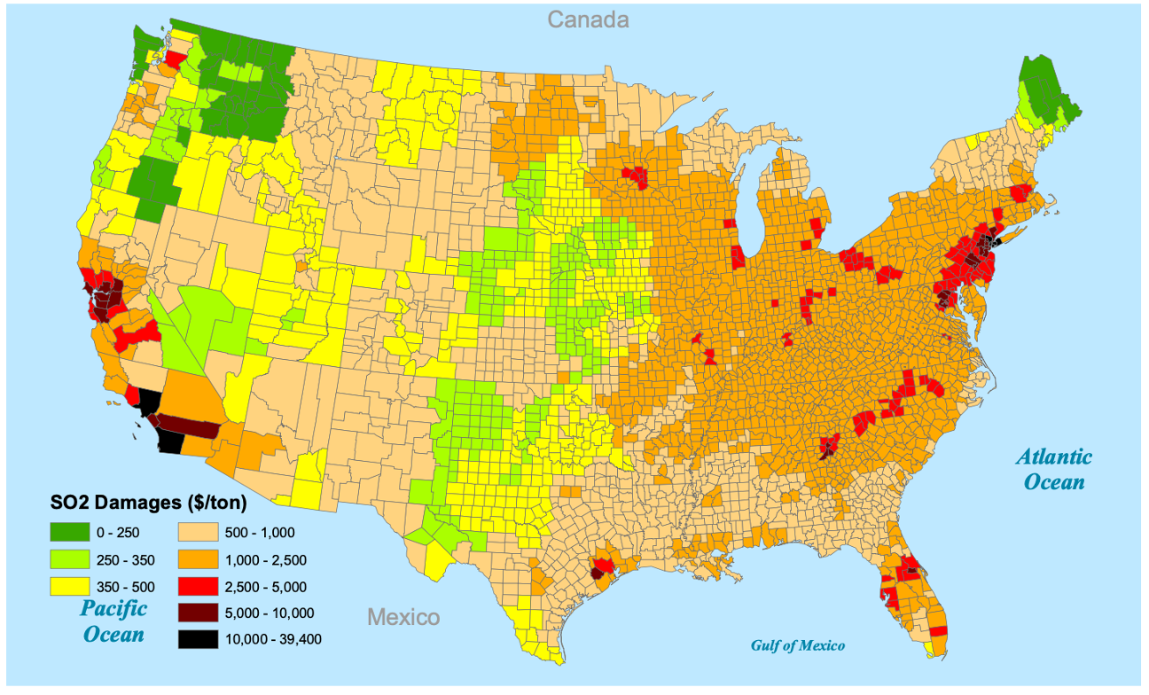
Figure 2. Marginal Damages from Ground Level SO2 Emitted in 2002

Source: Muller and Mendelsohn (2009)
Note: This figure illustrates the geographical variation in marginal damages due to SO2 emitted in 2002. The unit of damage is dollar per ton per year, in 2000 USD.
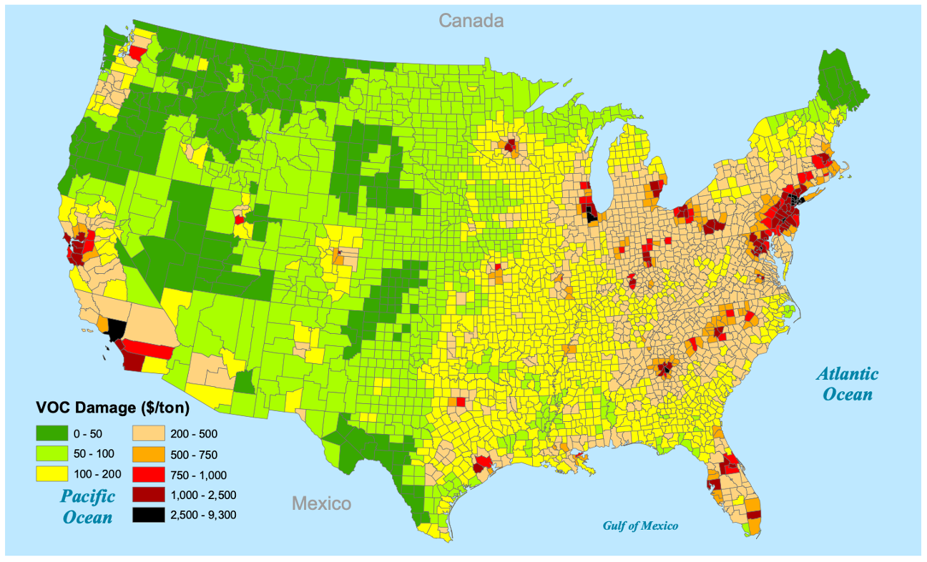
Figure 3. Marginal Damages from Ground Level VOCs Emitted in 2002

Source: Muller and Mendelsohn (2009)
Note: This figure illustrates the geographical variation in marginal damages due to VOCs emitted in 2002. The unit of damage is dollar per ton per year, in 2000 USD.
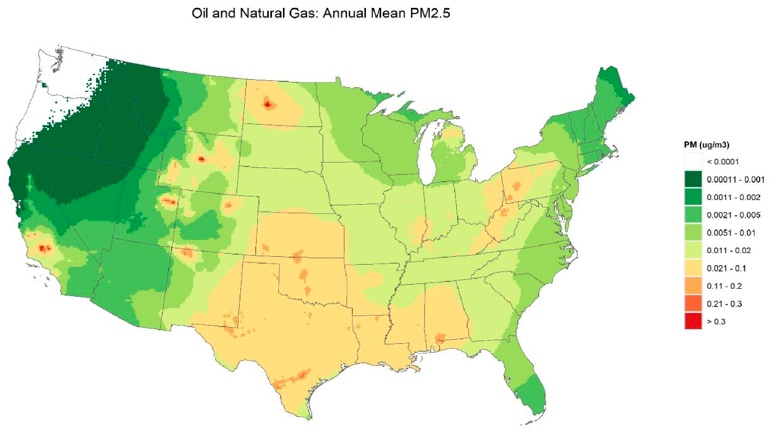
Figure 4. Impact on Ambient PM2.5 of Oil and Gas Extraction

Source: USEPA (2023a)
Note: This figure visualizes the estimated impacts of emissions from oil and gas extraction on annual average ambient PM2.5 in the U.S., measured in μg/m3.
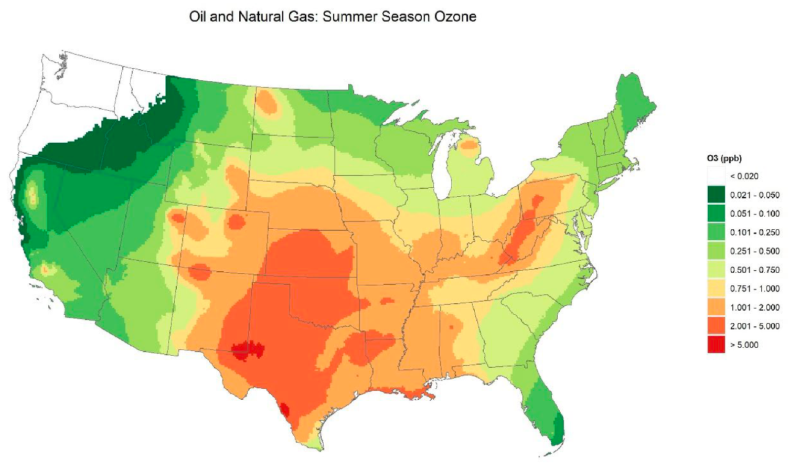
Figure 5. Impact on Ambient Ozone of Oil and Gas Extraction

Source: USEPA (2023a)
Note: This figure visualizes the estimated impacts of emissions from oil and gas extraction on the average of daily maximum 8-hour ambient ozone during the summer ozone season, measured in ppb.
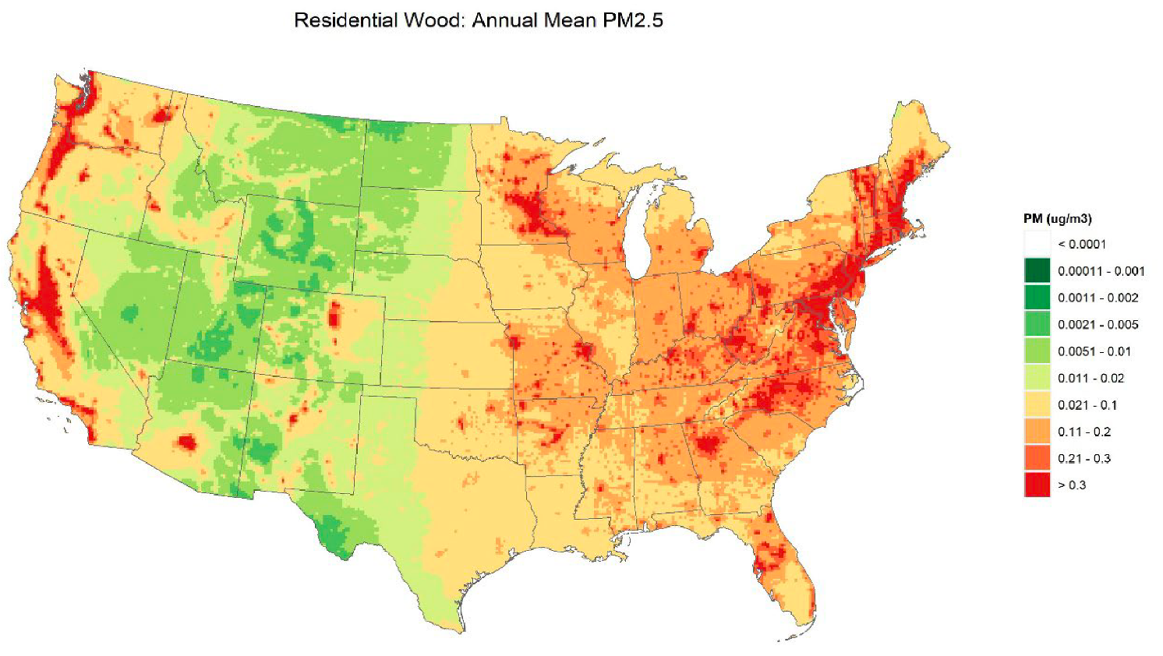
Figure 6. Impact on Ambient PM2.5 of Woodburning Stoves

Source: USEPA (2023a)
Note: This figure visualizes the estimated impacts of emissions from woodburning stoves on annual average ambient PM2.5 in the U.S., measured in μg/m3.

References
Ahmad, Y. J., S. El Serafy, and E. Lutz. (1989): Environmental Accounting for Sustainable Development, World Bank.
Chambers, M. (2023): “Proof of Concept for a U.S. Air Emissions Physical Flows Account,” BEA Working Papers.
Climate Impact Lab. “Data-Driven Spatial Climate Impact Model User Manual, Version 092022,” Data-driven Spatial Climate Impact Model User Manual, Version 092022, https://impactlab.org/research/dscim-user-manual-version-092022-epa/, Accessed 11/02/2023.
Corona, J., T. Doley, C. Griffiths, M. Massey, C. Moore, S. Muela, B. Rashleigh, W. Wheeler, S. D. Whitlock, and J. Hewitt. (2020): “An Integrated Assessment Model for Valuing Water Quality Changes in the U.S,” Land Economics, 96, 478–92.
Fixler, D., Julie L. Hass, Tina Highfill, Kelly Wentland, and Scott Wentland. (2023): “Accounting for Environmental Activity: Measuring Public Environmental Expenditures and the Environmental Goods and Services Sector in the US,” National Bureau of Economic Research.
Guignet, D., M. T. Heberling, M. Papenfus, O. Griot, B. Holland, D. Guignet, M. T. Heberling, M. Papenfus, O. Griot, and B. Holland. (2019): “Property Values and Water Quality: A Nationwide Meta-Analysis and the Implications for Benefit Transfer,” Working Paper.
Holland, S. P., E. T. Mansur, N. Z. Muller, and A. J. Yates. (2020): “Decompositions and Policy Consequences of an Extraordinary Decline in Air Pollution from Electricity Generation,” American Economic Journal: Economic Policy, 12, 244–74.
Howard, P. H., and T. Sterner. (2017): “Few and Not So Far Between: A Meta-analysis of Climate Damage Estimates,” Environmental & Resource Economics, 68, 197–225.
Joos, F., R. Roth, J. S. Fuglestvedt, G. P. Peters, I. G. Enting, W. von Bloh, V. Brovkin, et al. (2013): “Carbon Dioxide and Climate Impulse Response Functions for the Computation of Greenhouse Gas Metrics: A Multi-Model Analysis,” Atmospheric Chemistry and Physics, 13, 2793–2825.
Keiser, D. A., and J. S. Shapiro. (2018): “Consequences of the Clean Water Act and the Demand for Water Quality,” The Quarterly Journal of Economics, 134, 349–96.
Muller, N. Z. (2014): “Boosting GDP Growth by Accounting for the Environment,” Science, 345, 873-4.
Muller, N. Z., and R. Mendelsohn. (2007): “Measuring the Damages of Air Pollution in the United States,” Journal of Environmental Economics and Management, 54, 1–14.
---. (2009): “Efficient Pollution Regulation: Getting the Prices Right,” The American Economic Review, 99, 1714–39.
Muller, N. Z., R. Mendelsohn, and W. Nordhaus. (2011): “Environmental Accounting for Pollution in the United States Economy,” The American Economic Review, 101, 1649–75.
National Academies of Sciences, Engineering, and Medicine, Division of Behavioral and Social Sciences and Education, Board on Environmental Change and Society, and Committee on Assessing Approaches to Updating the Social Cost of Carbon. (2017): Valuing Climate Damages: Updating Estimation of the Social Cost of Carbon Dioxide, National Academies Press.
Nordhaus, W. D., and E. C. Kokkelenberg. (1999): Nature’s Numbers: Expanding the National Economic Accounts to Include the Environment, National Academies Press.
Rennert, K., F. Errickson, B. C. Prest, L. Rennels, R. G. Newell, W. Pizer, C. Kingdon, et al. (2022): “Comprehensive Evidence Implies a Higher Social Cost of CO2,” Nature, 610, 687–92.
Sacks, J. D., J. M. Lloyd, Y. Zhu, J. Anderton, C. J. Jang, B. Hubbell, and N. Fann. (2018): “The Environmental Benefits Mapping and Analysis Program – Community Edition (BenMAP–CE): A Tool to Estimate the Health and Economic Benefits of Reducing Air Pollution,” Environmental Modelling & Software, 104, 118–29.
United Nations. (2012): SEEA-Water System of Environmental Economic Accounting for Water,
Department of Economic and Social Affairs, Statistics Division, New York.

---. (2016): SEEA System of Environmental Economic Accounting -- Technical Note: Air Emissions Accounting. July.
USEPA. (2015): Benefit and Cost Analysis for the Effluent Limitations Guidelines and Standards for the Steam Electric Power Generating Point Source Category (Appendix H).
---. (2017a): “HAWQS v1.0 Calibration Process,”https://hawqs.tamu.edu/content/docs/calibration/HAWQS-Calibration-Methodology.pdf#/, Accessed 11/02/2023.
---. (2017b): “HAWQS (Hydrologic and Water Quality System),”https://www.epa.gov/waterdata/hawqs-hydrologic-and-water-quality-system, Accessed 11/02/2023.
---. (2022): Report on the Social Cost of Greenhouse Gases: Estimates Incorporating Recent Scientific Advances, National Center for Environmental Economics, Office of Policy, September.
---. (2023a): Estimating the Benefit per Ton of Reducing Directly-Emitted PM 2.5, PM 2.5 Precursors and Ozone Precursors from 21 Sectors, USEPA Office of Air and Radiation. September.
---. (2023b): “Sector-Based PM2.5 Benefit Per Ton Estimates,” USEPA BenMAP, https://www.epa.gov/benmap/sector-based-pm25-benefit-ton-estimates, Accessed 11/02/2023.
---. (2023c): “ICIS-NPDES Permit Limit and Discharge Monitoring Report (DMR) Datasets,” ICIS-NPDES Permit Limit and Discharge Monitoring Report (DMR) Datasets, https://echo.epa.gov/tools/data-downloads/icis-npdes-dmr-and-limit-data-set, Accessed 11/02/2023.

The criteria air pollutants are carbon monoxide (CO), sulfur dioxide (SO2), nitrogen dioxide (NO2), ozone (O3), lead (Pb) and particulate matter (PM10 and PM2.5).
APEEP, which translates emissions of PM2.5, PM10, VOCs, SO2, NOx and NH3 into ambient concentrations, has also been used to estimate and value air pollution damages in Muller and Mendelsohn (2007) and Muller and Mendelsohn (2009).
In APEEP the impact of a ton of emissions depends on the height at which it is emitted, as well as the geographic location at which it is emitted.
See USEPA (2023a, 2023b).
Ground-level ozone is formed when oxides of nitrogen (NOx) combine with volatile organic compounds (VOCs) in the presence of sunlight. When NOx is the limiting factor in this reaction, we say that ozone is NOx limited. In this case, reducing NOx will reduce ozone formation.
Global warming potential (GWP) measures how much energy a ton of GHG will absorb over a given time period; i.e., how much radiative forcing it will generate, relative to a ton of carbon dioxide (CO2). The CO2e of a gas is calculated by weighting its mass by its GWP.
The Ramsey formula discounts damages at time t to the present using a discount rate = ρ + ηg(t), where g(t) is the rate of per capita income growth at time t. Criteria for choosing the parameters ρ and η are described in USEPA (2022).
Estimates of agricultural damages in the GIVE model reflect consumer and producer surplus associated with changes in yields from temperature changes.
https://hawqs.tamu.edu/#/
Currently, about 30% of eight-digit hydrologic unit code (HUC-8) watersheds in the United States and about 25% of four-digit HUCs have been calibrated in HAWQS (USEPA 2017a; USEPA 2017b).
Nonuse values represent the benefits of knowing that a resource continues to exist even though an individual may never use it personally. Nonuse values are generally estimated using stated rather than revealed preference methods.

